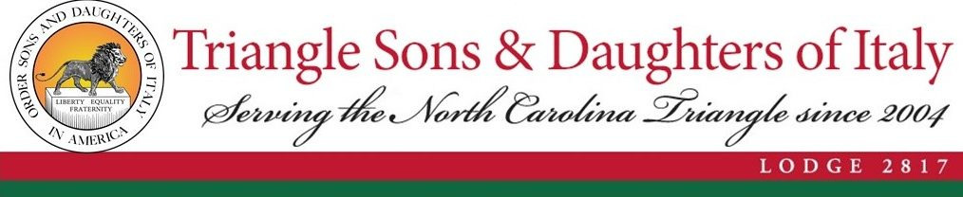

Outstanding Italian American in North Carolina Award

The winner will be honored during Italian Heritage Month at an event sponsored by the Triangle Sons & Daughters of Italy on Sunday, October 16th. The Triangle Sons & Daughters of Italy will publicize the winner on all its digital communications channels and will support the winner with a write-up if he or she has acceptable communications channels of their own where they wish to advertise winning the award.

Nominations may be completed by either the candidate or a third party

Nominations must be submitted via email to pat@dileonardo.net and received by 8/31/2022.

Nomination Form
Please complete as much as possible

Name of person making the nomination | Click or tap here to enter text.
Phone | Click or tap here to enter text.
Email | Click or tap here to enter text.

Candidate Name | Click or tap here to enter text.
Phone | Click or tap here to enter text.
Email | Click or tap here to enter text.
Address | Click or tap here to enter text.
Website address | Click or tap here to enter text.
Facebook Name | Click or tap here to enter text.
LinkedIn Name | Click or tap here to enter text.

Two references that may be contacted if deemed helpful

Name of 1st reference | Click or tap here to enter text.
Title: | Click or tap here to enter text.
Email | Click or tap here to enter text.
Phone | Click or tap here to enter text.
Name of 2st reference | Click or tap here to enter text.
Title: | Click or tap here to enter text.
Email | Click or tap here to enter text.
Phone | Click or tap here to enter text.

Describe the candidate's professional accomplishments
You may submit as an attachment to this form
It must include the following information if available

- Education
- Arc of candidate's career (Key positions held throughout career)
- Major career accomplishments
- Obstacles overcome
- Include links to biographical info, articles published, etc
- Describe the candidate's contribution to the Italian-American community
- Organizations served
- Impact on the Italian-American Community
- How the candidate has embraced their ancestry and values
- Describe how the candidate's contributions and career inspires other Italian-Americans

