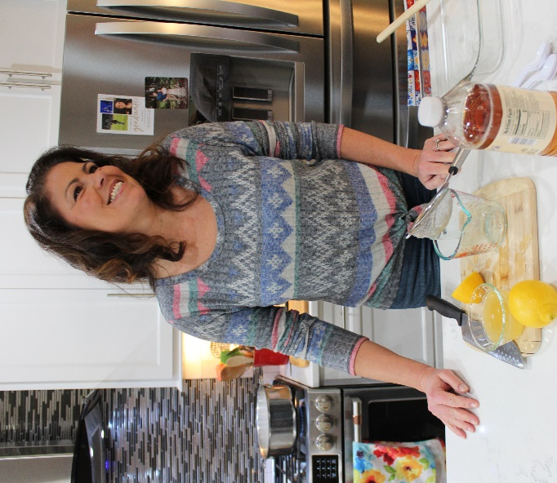
Homemade Ricotta
Laura’s Italian Kitchen – Downtown Wake Forest
(845) 282-5846
www.facebook.com/laurasitaliankitchen

Ingredients
¼ C Lemon Juice
Scant ¼ C (~3 oz) Apple Cider Vinegar
9 C Whole Milk
3 C Heavy Cream
Cheesecloth
Sea Salt

Directions
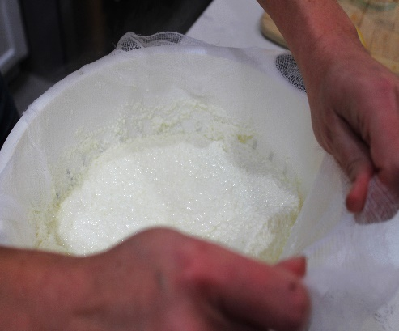
- Measure out into a dish 1/4 cup lemon juice and close to 1/4 cup apple cider vinegar.
- In a heavy bottom wide sauce pan bring 9 c of whole milk, 3 c of heavy cream and a pinch of salt to just about starting to boil.
- Remove from heat and add the acid stirring gently about 15 times.
- Let sit undisturbed for about 20 minutes.
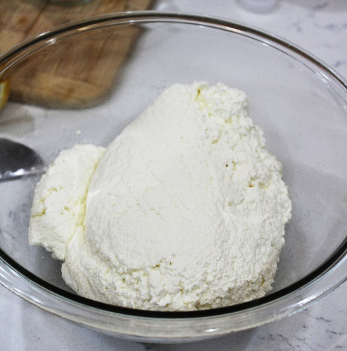
- Line a colander with two single layers of cheese cloth. With a serving spoon, spoon large chunks of the curd on top into the colander. Then gently and slowly pour the rest of the pot into the colander.
- Leave it alone for about a minute, then begin tugging the sides of the cheesecloth (see photo) forming a ball of cheese. If you get bits stuck to the cloth scrape them back into the ball.
Begin pulling alternate sides of the cloth to “flip the cheese over in the cloth. Wait about a minute and flip the other way. Do this till you reach the desired consistency. (Keep in mind it seems looser when warm.)
- Lift the corners of the cheesecloth and “roll” it into a bowl. Salt until it tastes a little salty and stir until creamy.
- Eat warm or store in a closed container in the refrigerator for up to 10 days.
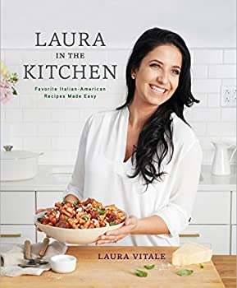

Laura in the Kitchen: Favorite Italian-American Recipes Made Easy: A Cookbook
by Laura Vitale
Laura in the Kitchen: Favorite... book by Laura Vitale (thriftbooks.com)

YouTube
https://www.youtube.com/user/LauraVitalesKitchen

